Field Trip Activities on Lamma Island
Set 1

Name: ________________( ) | S. _______ | Date: _____________
Stop 1 Yung Shue Wan Main Street

Part 1 Rubbish – what’s the solution?
- What sustainable method is used to deal with waste in Yung Shue Wan?
Separation of waste for recycling.
- List three benefits of using the method mentioned in Question 1.
- Reduce environmental damage caused by extracting natural resources, e.g. wood, oil.
- Conserve natural resources.
- Reduce waste disposal and the pressure on landfills.
3. Work in groups and walk along the main street. Find out the collection points for recyclable materials. On the map below (Figure 1), mark and label the area where they are for each of the following products with corresponding letters.
- Paper (b) Plastics (c) Metal s (d) Glass bottles
(e) Rechargeable batteries (f) Clothes (g) Small electrical appliances
Figure 1
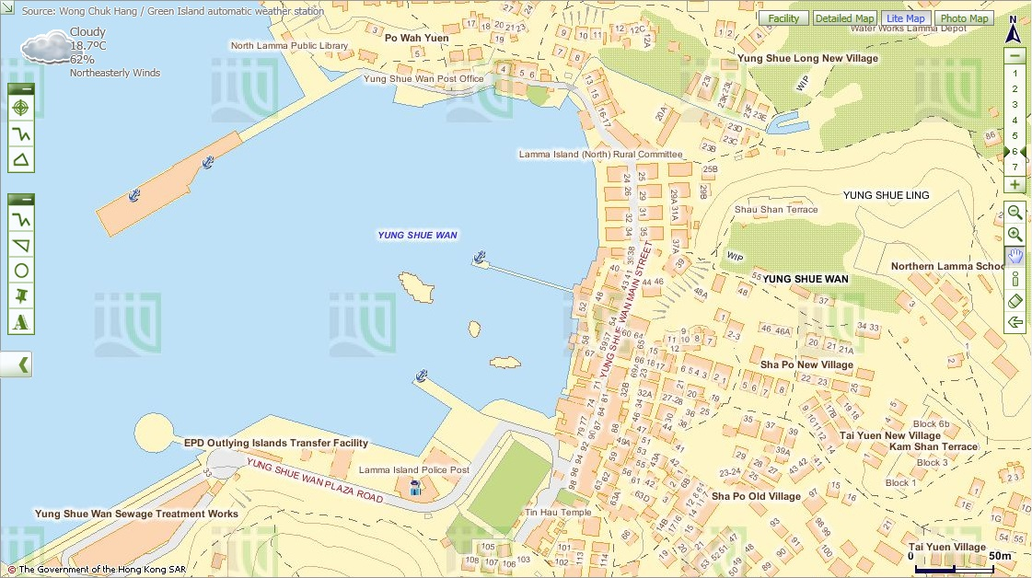
Police
Post
Map from Lands Department
- Evaluate whether the waste separation and recycling scheme is successful:
- Are all items mentioned in Question 3 collected for recycling? If not, which
item(s) is / are not collected?
Any reasonable answers.
- Are recycling collection points accessible? Any reasonable answers.
- Are recycling collection points enough for the public? Give evidence to
support your answer.
Any reasonable answers.
- Suggest two ways to improve the scheme so that more people, including visitors use it more often.
- Increase the number of recycling collection points.
- Provide more types of recycling bins for recycling rechargeable batteries and small electrical appliances.
or any reasonable answers.
Part 2 Closed loop recycling – what is it?
Visit ‘Lamma Corner’.
- Find out what three types of recyclable materials mentioned in Part I Question 3 are used for making the items.
Recyclable materials | Uses (Give at least one example)
Glass | Bracelets
Plastic bottles | Decoration
Cloth | Bags
or any reasonable answers
- Figure 2 shows the closed loop recycling that is practised on Lamma Island.
Figure 2
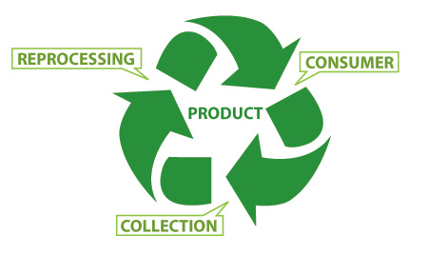
MANUFACTURING
COLLECTING
PURCHASING

The closed loop recycling involves three processes, including
- Collecting waste for recycling
- Manufacturing recycled materials into new products
- Purchasing recycled-content products
- How can this closed loop recycling help combat climate change?
- Less waste is disposed in landfills and thus less methane is produced.
- Reduce the energy used during extraction of natural resources and manufacturing. As there are less fossil fuels being burned, emission of carbon dioxide is reduced.
- Reduce air pollution during manufacturing.
or any reasonable answers.
- As a consumer, what roles should you play in the recycling loop to help combat climate change?
- Collect recyclable materials.
- Purchase recycled-content products.
or any reasonable answers.
- Do you think that all recyclable materials collected can enter the loop of recycling? Why?
No.
- The product is low value-added.
- Difficult and expensive to retrieve materials for processing.
- Lack of technical support.
or any reasonable answers.
- (a) If the recyclable materials cannot be used for recycling, where will they go?
Landfills.
Taking into consideration of your answers in (a) and (b), do you think
recycling is a good way to combat climate change? What else can we
do to combat climate change?
- Do you think all the recyclable materials are recycled locally in Hong Kong? Why?
No, recycling industry is not profitable in Hong Kong.

- Taking into consideration of your answers in (a) and (b), do you think recycling is a good way to combat climate change? Why? What else can we do to combat climate change?
- Yes, less waste goes to landfills. /No, reduce, reuse and replace are better than recycling as energy is used in the recycling process.
- Save energy.
- Take public transport.
or any reasonable answers.

Part 3 Eco shopping
Work in groups and walk along the street.
- Go to one of the green shops and select two types of packaged food that you think they are environmentally-friendly. Complete the following table based on the information on their labels.
 | Food A | Food B
- Name of food
- Is the food homemade? If not, where is it produced? | Yes No  If no,  Hong Kong  The Mainland  Other countries | Yes No  If no,  Hong Kong  The Mainland  Other countries
- Is the food made from organic farms?
- Number of ingredients
- Do the ingredients come from plants or animals? Give two examples. | Plants Animals  Both  Examples:  _____________________  _____________________ | Plants Animals  Both  Examples:  _____________________  _____________________
- What is/are the packaging material(s)? | plastic bag  paper  others _____________ | plastic bag  paper  others: _____________

2. Which food would you like to buy in order to reduce more carbon emission? Give three reasons to support your answers.
Any reasonable answers.

Stop 2 A Local Farm
- Work in groups. Observe the operation of this farm and interview the farmer. Complete the following table.
Questions | Answers
- How to improve soil  quality? | using chemical fertiliser  using compost  covering soil with mulches  crop rotation  fallowing  agroforestry: trees are grown with crops  others _______________________
(b) How to avoid pest? | using chemical pesticide  using CD-ROMs  using plastic balls  growing different types of crops  crop rotation  growing companion crops  using insect trap  others _______________________
(c) How to use water resource? | constructing wells  building water tanks or ponds  covering soil with organic matter  using drip irrigation  others _______________________
- What tools are used for farming? | using simple tools, e.g. hoe  using machines, e.g. ___________
(e) What is the useful output? | crops, e.g. tomatoes, lettuce  animal products, e.g. ___________

- Do you think this way of operation of farm can reduce carbon emissions? Give reasons.
 | Can it help to reduce carbon emission? Put ‘’ or ‘’ | If yes, how can this help to reduce carbon emission?
- Way of improving soil quality |  | Answer for (a), (c) and (d):  - Less fossil fuels are used to make fertilisers and generate electricity to pump water and drive machines. As there are less fossil fuels being burned, emission of carbon dioxide is reduced.
- Way of avoiding pest
- Way of using water resource
- Tools used for farming
- Type of output |  | Vegetables  - No livestock is reared, thus reducing the production of methane.
- Would you like to buy agricultural produce grown in this type of farm for reducing climate change? Give reasons to support your answers.
Yes.
- It is because the soil is not fertilised by chemicals and therefore it does not pose a health risk.
- Less pollution is created as there are no fossil fuels being burned.
or any reasonable answers.

Stop 3 Viewing at Lamma Power Station

- Write the letters in the space provided to show the components of power station in Figure 3.
Components of Power Station:
- Coal-fired Generating Units | - Gas-fired Combined-cycle Generating Units | - Oil-fired Generating Units
- Coal Yard | - Ash Lagoon | - Transport jetty

Figure 3 Components of Power Station
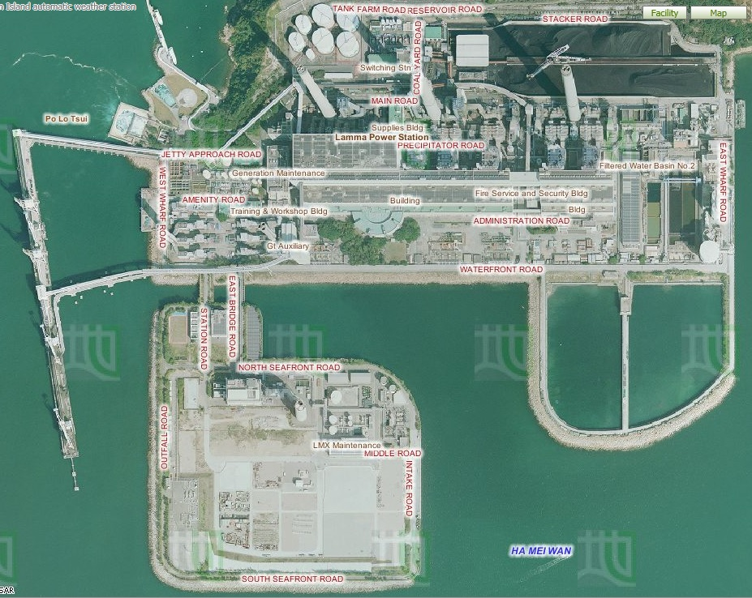
6. b
1. a
Lamma Power Station Extension
2. f
4. e
5. c
3. d

Aerial Photos from Lands Department

- Describe and explain the locational advantages of the power station.
Locational characteristics | Reasons
Is it located near the coast?  Yes | - Easier import of fuel by cheap sea transport.  - Need water for cooling.
Is it sheltered by hills?  Yes | - The impact caused by adverse weather condition is reduced.
Is it near the residential areas? No | - High risk of fire explosion.  - Air pollution is serious.

- Table 4 shows the capacity of the Lamma Power Station.
Table 4 Capacity of the Lamma Power Station in 2013

 | Number of units | Capacity of each unit (MW) | Total capacity (MW)
Coal-fired Generating units | 3 | 250 | 750
 | 5 | 350 | 1750
Oil-fired Generating Units | 4 | 125 | 500
 | 1 | 55 | 55
Gas-fired Combined-cycle Generating Units | 1 | 335 | 335
 | 1 | 345 | 345
Solar Power System |  |  | 1
Lamma Winds |  |  | 0.8
Total |  |  | 3736.8
Source: HK Electric
https://www.hkelectric.com/en/MediaResources/Documents/LPS_2014.pdf
- What energy source (Hint: a type of fuels) is mainly used in the electricity generation? What do they include? Are they renewable?
Fossil fuel is mainly used. It includes coal, petrol and natural gas. They are not renewable.
- (b) Among these fuels, which one is mainly used to generate electricity in
- the power station? Which one has been increasingly used to generate
- electricity recently? (Hint: Think about what kind of generating unit
- has been built in the newly-reclaimed area)
- (b) Among these fuels, which one is mainly used to generate electricity in
- the power station? Which one has been increasingly used to generate
- electricity recently? (Hint: Think about what kind of generating unit
- has been built in the newly-reclaimed area)
- Among these fuels, which one is mainly used to generate electricity in
- the power station? Which one has been increasingly used to generate
- electricity recently? (Hint: Think about what kind of generating unit
- has been built in the newly-reclaimed area)
(b) Among the fuels mentioned in (a), which one is mainly used to generate electricity in the power station? Coal.
(c) What kind of fuels has been increasingly used to generate electricity recently? (Hint: Think about what kind of generating unit has been built in the newly-reclaimed area?) Natural gas.
4. Observe the power station. Does the power station cause air pollution? If yes, what kinds of air pollutants are released? Yes, carbon dioxide, sulphur dioxide and nitrogen oxide.
5. Figure 5 shows the amount of air pollutants emitted from coal-fired and gas-fired generating units respectively when the total electricity generation in the year 2012 would increase by 2.57 times compared with that in 1990.
Figure 5 Amount of Air Pollutants Emitted from the Coal-fired and Gas-fired Units
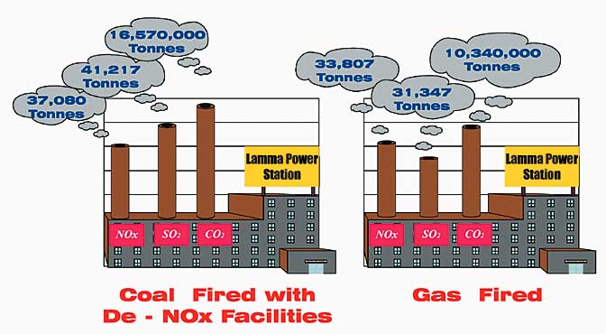

Source: Environmental Protection Department, HKSAR Government
http://www.epd.gov.hk/eia/operation/english/chapter05_4.html
- Why does the power station cause climate change?
The burning of fossil fuels for generating electricity will emit large amount of greenhouse gases (CO2). The greenhouse gases trap heat in the atmosphere and intensify greenhouse effect, causing global warming.
- More generating units will be built to generate more electricity in future. Explain why.
It is because of population growth and rapid economic development.
or any reasonable answers.
- Which kind of fossil fuels, coal or natural gas, should be more widely-used in the new generating units? Explain why.
Natural gas: cleaner energy, thus reducing pollutants and greenhouse gases. This helps mitigate climate change.
- Do you think that using a mixture of different types of fossil fuels only can help to minimise climate change in future? Why?
No. Natural gas can reduce carbon emission but the increase in demand of electricity still causes the combustion of more natural gases, resulting in more carbon emission.
or any reasonable answers.

Stop 4 Lamma Winds
Is the use of renewable energy a way out in Hong Kong?

- What types of renewable energy are used at this site?
Wind and solar energy.
- Why is it suitable to set up the wind turbine at this site? Give five reasons.
- Far away from ecological sensitive area
- Wind speed sufficient for electricity generation
- Accessible by road
- Open land without obstacles to block the wind
- Proximity to existing power grid
- Far away from residential areas

Is it easy to find similar site to build wind farm in Hong Kong? Why?
It is not easy because it is hard to find a large and open land without obstacles to block the wind.
- Collect the data at the tower base of the wind turbine and complete the following table.
Date & time | 12 Jan 2017 at  10:34 p.m.
Present wind speed | 5.9 m/s | m/s
Present power output | 198.1 kW | kW
Cumulative electricity generated | 9442719 kWh | MWh
Amount of carbon dioxide (CO₂) saved | 7868932 kg | tonnes
Remarks: The units of cumulative electricity generated and amount of carbon dioxide saved shown on HK Electric’s website are different from those shown at the tower base of the wind turbine.
What is the relationship between wind speed and power output?
Positive relationship.
- In 2013, the electricity consumption was 44.21 billion kWh in Hong Kong. Do you think that this wind turbine generates a lot of electricity? Give evidence to support your answer.
No, the amount of electricity generated by wind turbine is very small. It only accounts for very low percentage of total electricity consumption.

Explain why this wind turbine cannot be designed to produce a lot of electricity.
- Wind condition is unstable.
- Wind speed is not very high.
- Moderate height restriction.
- Current technology is limited.
or any reasonable answers.
- By observation, list the environmental problem(s) caused by the wind turbine.
It may threaten birds and create visual and noise pollution.
- Should different types of renewable energy, particularly solar energy and wind energy, be further developed in Hong Kong?
Each group will be assigned one of the following roles. Collect the information from the exhibition panels for discussion.
Role | Tasks
Government | Discuss why different types of renewable energy should be further developed in relation to existing environmental problems
Spokesman from a power company | Discuss whether the development of different types of renewable energy is cost-effective
Environmentalist | Discuss the negative impact of the development of different types of renewable energy on the environment
Urban planner | Discuss the problems in the selection of suitable sites for the development of different types of renewable energy
Spokesman from Department of Energy | Discuss whether different types of renewable energy can give abundant and reliable energy supply in Hong Kong and their energy efficiency
Your role: Any reasonable answers.
Your opinion: Any reasonable answers.

- Do you agree that the renewable energy should be further developed in Hong Kong as a sustainable measure against global warming? Why?
Strongly disagree Disagree Agree Strongly agree
Give at least three reasons:
Any reasonable answers.
- The use of technical measures, like fuel mix and renewable energy, seems not to be the most sustainable way to combat climate change caused by power station. Then what else can we do to solve this problem?
- People can develop green habits and reduce waste disposal.
- People can reduce energy consumption and choose energy-efficient appliances.
or any reasonable answers.

Stop 5 Hung Shing Yeh Beach Tree Planting Site
- Read the information from an interpretive plate. What are the two types of trees? Give one example of each type of trees.
Type | Example
Exotic species | Earleaf Acacia
Native Species | Ivy Tree

- Which type of trees is chosen for plantation at this site? Why?
Exotic Species. It is because they are able to grow faster even after small hill fire. They allow faster regeneration of forest.
- How can the planting of trees help reduce climate change?
Trees absorb carbon dioxide through photosynthesis. The increase in tree cover helps absorb carbon dioxide.
- Apart from planting of trees, what else can we do to help reduce climate change at this site? Suggest at least two methods.
i. Protect the trees.
ii. Reduce the use of paper which helps curb deforestation.
or any reasonable answers.

Stop 6 The Home Farm

At Lo So Shing Village, observe the activity held outside the village houses
- What activity is carried out outside the village houses? Farming.
- Can you find a large piece of farmland? No.
- What agricultural produce is grown from the farm?
Vegetables.
- Do you think that the produce is for self-consumption only? Give reason to support your answer.
Yes, it is because the size of farmland and the output are small.
or any reasonable answers.
- How can the growing of our own food help reduce carbon emission in Hong Kong?
Save fuel for transportation, production or packaging. As there are less fossil fuels being burned, carbon emission is reduced.
- Could you grow your own food at home? Why or why not?
No, there is only limited space.
- What else can we do for food supply to reduce climate change?
- Eat locally-produced food
- Choose a diet with more vegetables and less meat.

Stop 7 Mudflat

- What are the characteristics of mudflat?
- What is its relief? Flat, low-lying land.
- What is made up of the mudflat? Sand and mud.
- Does the depth of water vary from time to time? Yes.

- What kinds of living organisms live in the mudflat?
 | Examples
Plants | Mangrove
Wetland Animals | Fiddler Crabs, Mudskippers, Little egret, Shellfish
- What does Mudflat provide for these living organisms?
Habitat.
- Do all the animals live in the water all the time? No.
- How will climate change affect the water level in the mudflat?
Melting of sea ice causes water level in the mudflat to rise.
- How will the change in the water level affect the living organisms?
The living organisms will be under water all the time. Some cannot find their food and may die, causing extinction of some species.
- What should you do to protect these living organisms in our daily life?
- Use less paper.
- Save energy.
- Consume locally produced products.
or any reasonable answers.

